

Simple Calculator Application

**Introduction:** This project demonstrate the creation of a simple calculator application capable of performing basic arithmetic operations such as addition, subtraction, multiplication, and division. The goal is to help beginners understand the structure of a basic program, user input handling, and function usage in programming.

**Code:**

**#include <stdio.h>**

**int main() {**

**int choice;**

**float num1, num2, result;**

**printf("Simple Calculator Application\n");**

**printf("\n");**

**printf("1. Addition\n");**

**printf("2. Subtraction\n");**

**printf("3. Multiplication\n");**

**printf("4. Division\n");**

**printf("Enter your choice (1-4): ");**

**scanf("%d", &choice);**

**printf("Enter first number: ");**

**scanf("%f", &num1);**

**printf("Enter second number: ");**

**scanf("%f", &num2);**

**switch(choice) {**

**case 1:**

**result = num1 + num2;**

**printf("Result: %.2f\n", result);**

**break;**

**case 2:**

**result = num1 - num2;**

**printf("Result: %.2f\n", result);**

**break;**

**case 3:**

**result = num1 * num2;**

**printf("Result: %.2f\n", result);**

**break;**

**case 4:**

**if(num2 != 0) {**

**result = num1 / num2;**

**printf("Result: %.2f\n", result);**

**} else {**

**printf("Error: Division by zero is not allowed.\n");**

**}**

**break;**

**default:**

**printf("Invalid choice! Please select between 1 and 4.\n");**

**}**

**return 0;**

**}**

---------------------------------------------------------------------------------------------------------------------

**Result:**

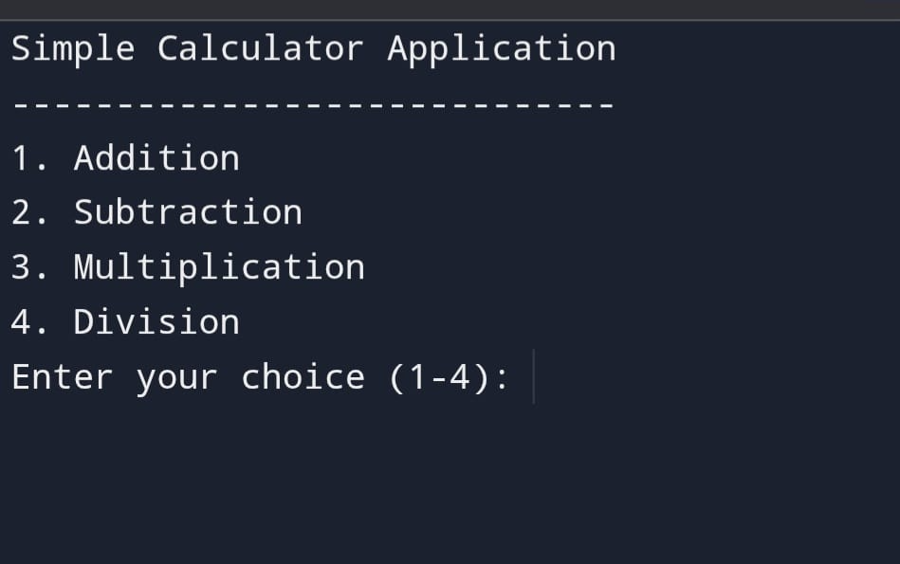

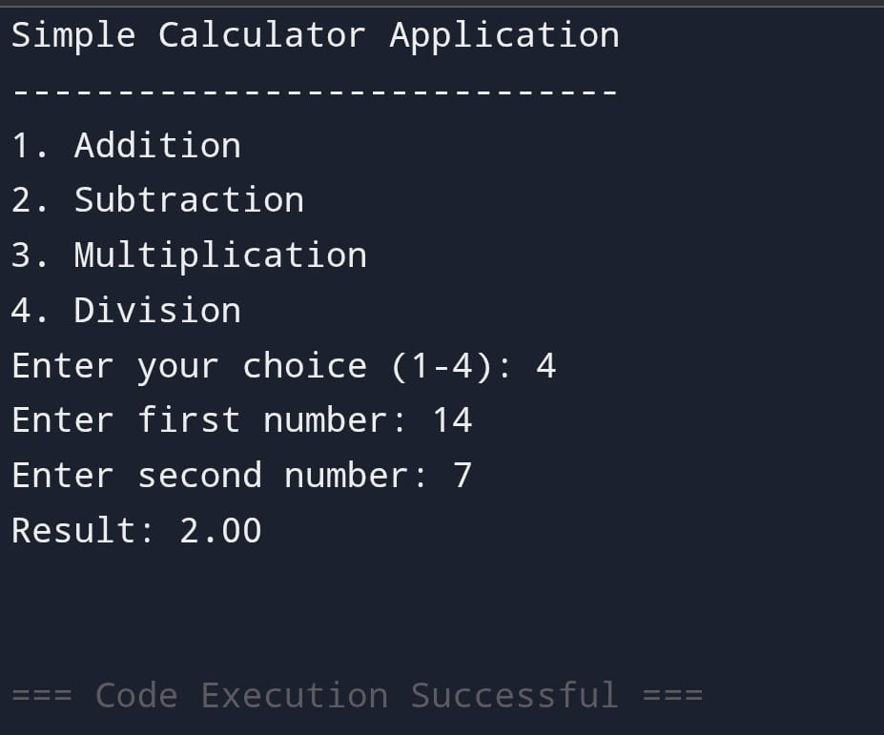

**✨ Future Enhancement For A Simple Calculator Application✨**

1. Graphical User Interface (GUI)

->Add buttons, display screens, and an interactive layout using frameworks like Tkinter, JavaFX, or NET.

->Makes the calculator more user-friendly and visually appealing.

2. Scientific Calculator Features

->Include advanced functions:

√, %, sin, cos, tan, log, exponent, factorial, etc.

->Turns a basic calculator into a tool for science and engineering users.

3. Memory Functions

->Add features like M+, M-, MR (Memory Recall), MC (Memory Clear).

->Helps users store and retrieve previous calculations.

4. Error Handling Improvements

->Detect invalid inputs, divide-by-zero, overflow errors, and give meaningful messages.

->Makes the app more robust and reliable.

5. History / Log System

->Store past calculations for review.

->Add export options (PDF, text file, etc.).

6. Voice Input & Output

->Users can speak numbers and operators.

->The calculator responds with voice output for accessibility.

7. Multi-language Support

->Interface and messages available in different languages.

->Makes the calculator accessible to a wider audience.

8. Cross-Platform Deployment

->Convert the calculator into:

---A mobile app (Android/iOS)

---A web app (using HTML/CSS/JavaScript)

---A desktop app

->Increases usability across devices.

9. Custom Themes & Personalization

->Light mode, dark mode, color themes.

->Users can customize the look according to their preference.

10. AI-Powered Features

->Step-by-step solution explanation.

->Auto-correction of input.

->Smart suggestions for operations.

Advanced Calculator:

#include <stdio.h>

#include <math.h>

float memory = 0; // Memory feature (M+, M-, MR, MC)

void showMenu() {

printf("\n========== ADVANCED CALCULATOR ==========\n");

printf("1. Addition\n");

printf("2. Subtraction\n");

printf("3. Multiplication\n");

printf("4. Division\n");

printf("5. Square Root\n");

printf("6. Power (x^y)\n");

printf("7. Logarithm (base 10)\n");

printf("8. Sine (sin x)\n");

printf("9. Cosine (cos x)\n");

printf("10. Tangent (tan x)\n");

printf("\n--- Memory Functions ---\n");

printf("11. M+ (Add to memory)\n");

printf("12. M- (Subtract from memory)\n");

printf("13. MR (Memory Recall)\n");

printf("14. MC (Memory Clear)\n");

printf("-----------------------------------------\n");

printf("Enter your choice: ");

}

int main() {

int choice;

float a, b, result;

while (1) {

showMenu();

scanf("%d", &choice);

switch (choice) {

case 1:

printf("Enter two numbers: ");

scanf("%f %f", &a, &b);

result = a + b;

printf("Result = %.2f\n", result);

break;

case 2:

printf("Enter two numbers: ");

scanf("%f %f", &a, &b);

result = a - b;

printf("Result = %.2f\n", result);

break;

case 3:

printf("Enter two numbers: ");

scanf("%f %f", &a, &b);

result = a * b;

printf("Result = %.2f\n", result);

break;

case 4:

printf("Enter two numbers: ");

scanf("%f %f", &a, &b);

if (b == 0)

printf("Error: Division by zero!\n");

else {

result = a / b;

printf("Result = %.2f\n", result);

}

break;

case 5:

printf("Enter a number: ");

scanf("%f", &a);

if (a < 0)

printf("Error: Cannot find sqrt of negative number!\n");

else

printf("Result = %.2f\n", sqrt(a));

break;

case 6:

printf("Enter base and exponent: ");

scanf("%f %f", &a, &b);

printf("Result = %.2f\n", pow(a, b));

break;

case 7:

printf("Enter a number: ");

scanf("%f", &a);

if (a <= 0)

printf("Error: Log undefined for zero or negative numbers!\n");

else

printf("Result = %.2f\n", log10(a));

break;

case 8:

printf("Enter angle (in degrees): ");

scanf("%f", &a);

printf("Result = %.2f\n", sin(a * M_PI / 180));

break;

case 9:

printf("Enter angle (in degrees): ");

scanf("%f", &a);

printf("Result = %.2f\n", cos(a * M_PI / 180));

break;

case 10:

printf("Enter angle (in degrees): ");

scanf("%f", &a);

printf("Result = %.2f\n", tan(a * M_PI / 180));

break;

case 11:

printf("Enter number to add to memory: ");

scanf("%f", &a);

memory += a;

printf("Memory Updated! (M = %.2f)\n", memory);

break;

case 12:

printf("Enter number to subtract from memory: ");

scanf("%f", &a);

memory -= a;

printf("Memory Updated! (M = %.2f)\n", memory);

break;

case 13:

printf("Memory Recall: M = %.2f\n", memory);

break;

case 14:

memory = 0;

printf("Memory Cleared!\n");

break;

default:

printf("Invalid choice! Please try again.\n");

}

}

return 0;

}

Including CSS:-

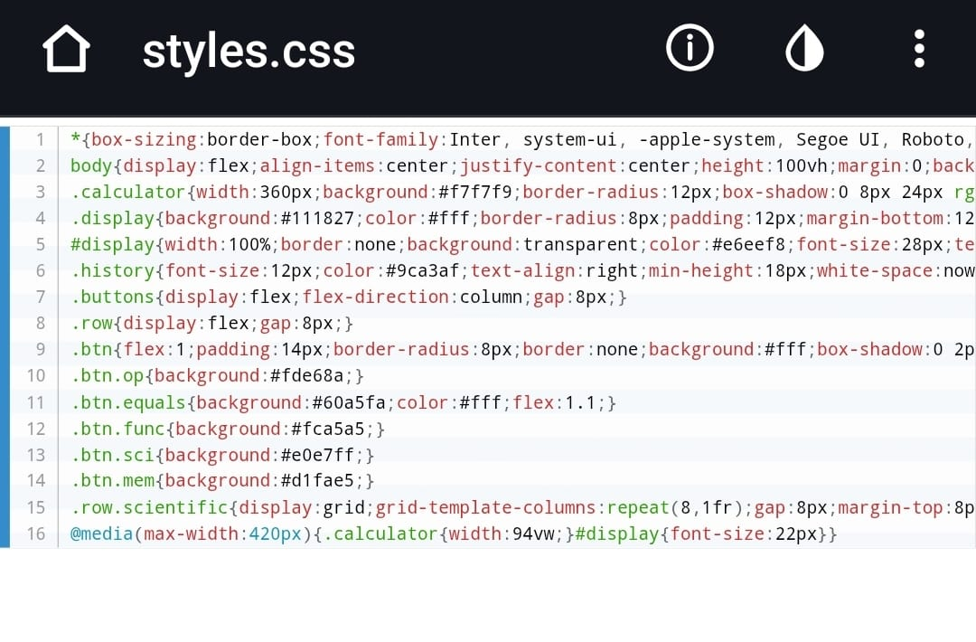

Including Java Script:-

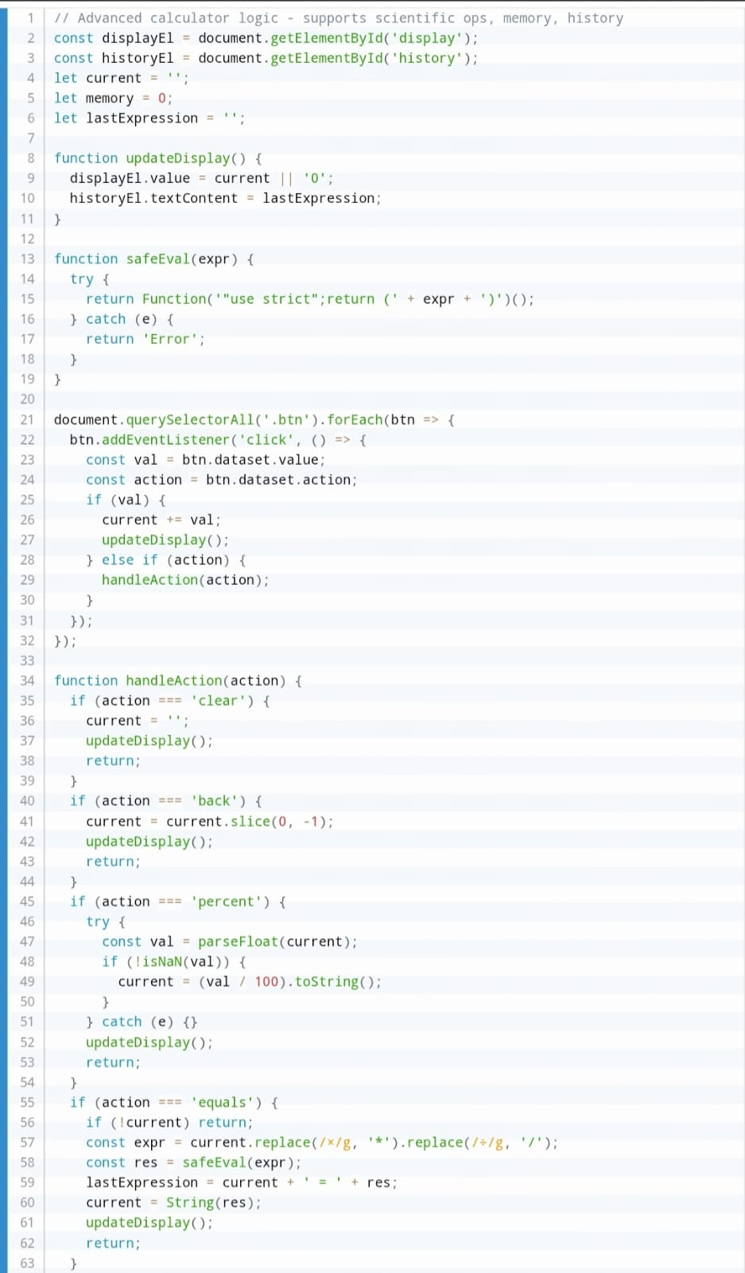

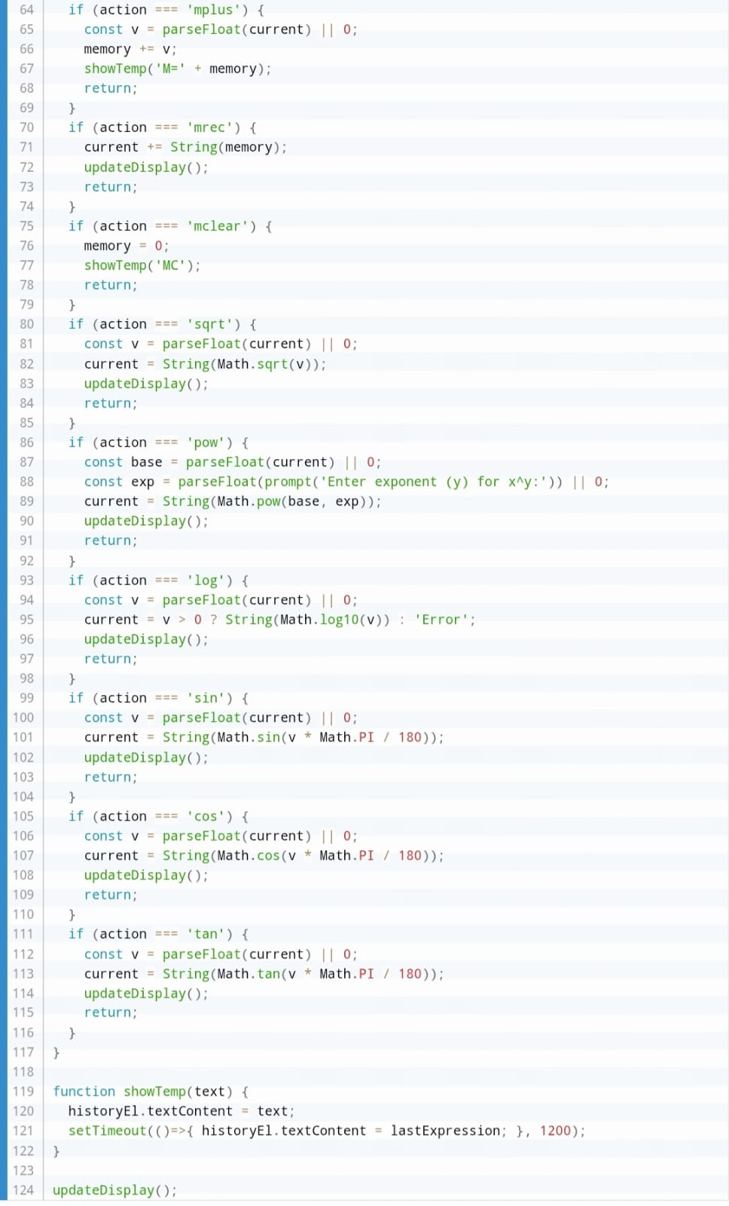

Including HTML:-

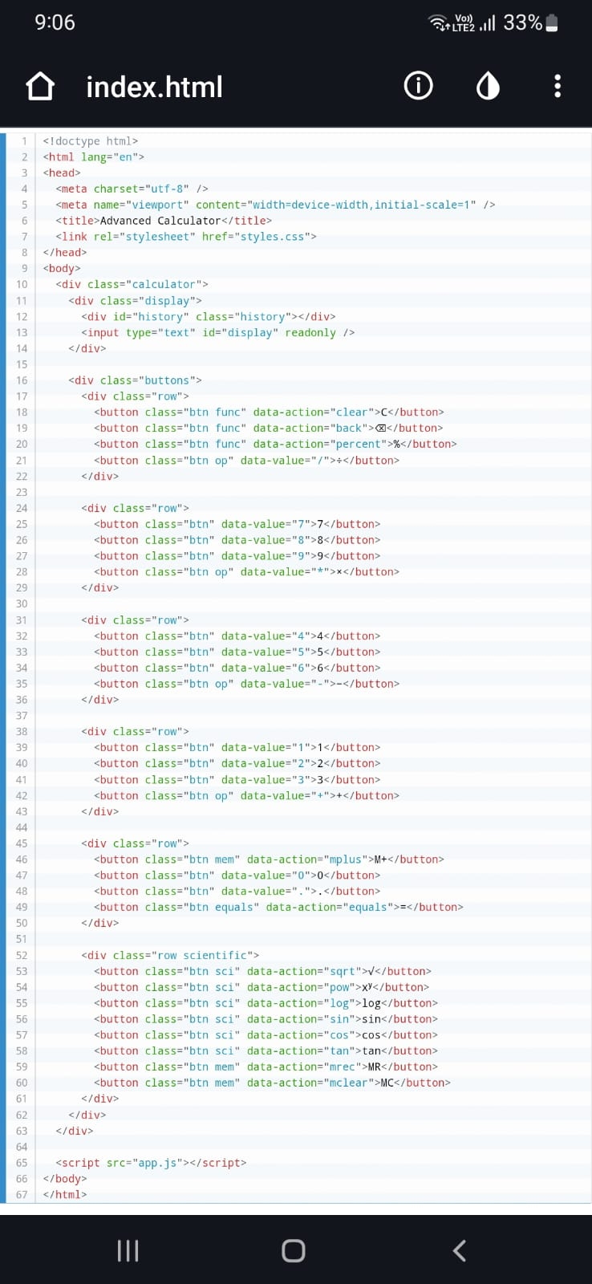

Result=

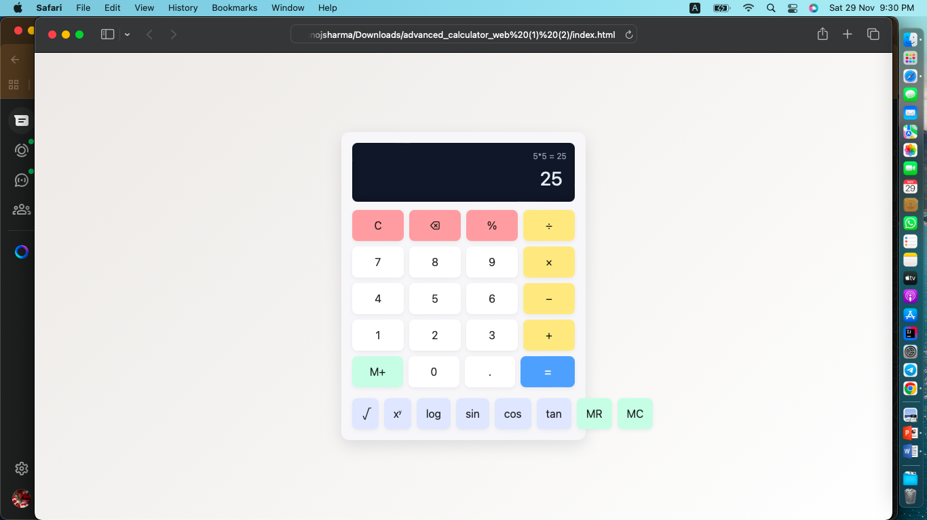

**Deployment Link:-**

**https://github.com/liesa9922-debug/simple-to-Advance-Calculater.git**